SWE30010

HRM PROPOSAL FOR GEMADEPT

Name: Nguyen Dinh Nhat Minh  
ID: 103802490  
Tutor: Thomas Hang

**HRM WEBSITE QUALITY CHECKLIST**

|  |  |  |
| --- | --- | --- |
| **Functional Suitability – Functional Correctness** | | |
| No. | Metrics | Thresholds |
| 1 | Individually, each calculation module (e.g., payroll, time worked, rating) should have little to no calculation errors. | < 5% calculation error |
| 2 | When a calculation is made in any one of the modules, the related attribute in other modules must update correctly. | < 5% calculation error |
| 3 | Employee’s information updates should correctly appear on the screen. | 100% accuracy |
| 4 | Employee's information should be recorded correctly within the database | 100% accuracy |
| 5 | The dashboard chart should be used properly to show clear details of employee’s information. | Clear visualization with < 5% deviation |
| 6 | The database searching and filtering options should return the correct result. | 95% accuracy |
| 7 | Biometrics token must be correctly verified and apply for the correct personnel | 95% accuracy |
| 8 | Data conversion of the fingerprint to be stored in the database must be accurate for each of the employees. | < 5% fingerprint data conversion error |
| 9 | During the account registration process, important fields such as name, password, and email are required. | 100% of the information is fulfilled |
| 10 | Most authentication attempts must be successful | 90% success rate |
| 11 | The website must pass many test cases that prevent XSS and exploiting URLs. | 98% test case passed |
| 12 | Proper input sanitization should be checked to prevent code injection or unintended characters. Additionally, handling of special characters, whitespace, and input encoding should be validated. | 100% input fields are protected |
| 13 | Form submission and data transmission should be tested to ensure that data is correctly processed and sent. | 95% test case passed |
| 14 | Error messages should be displayed when invalid data is entered, providing clear instructions on how to correct them. | 100% accuracy |
| 15 | Links to different functionalities should be correct. | 100% accuracy |
| 16 | API connection to other services (i.e., existing ERP, Google sign in, Google sheet, etc.) should have little error | < 5% API errors |
| 17 | The website should display and run as expected on various browsers. | 98% of browser tested must passed |

**Conducting Quality Control**

With the quality defined, we proceed to conduct .

1. **Heading**

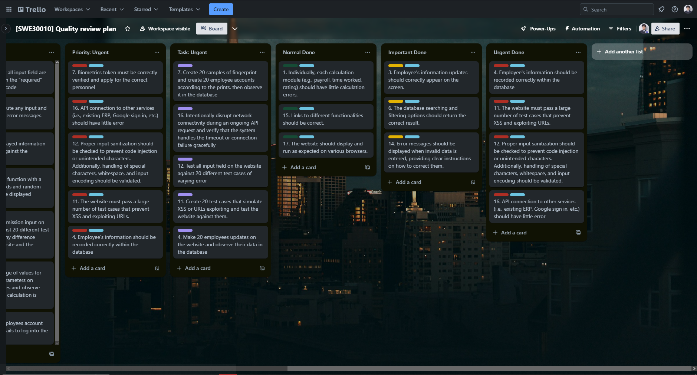

*Figure 1.1: Trello*

1. **Heading**

*Figure 2.1: Risk assessment chart*

1. **Heading**

*Figure 3.1: Quality Review Plan Trello board*